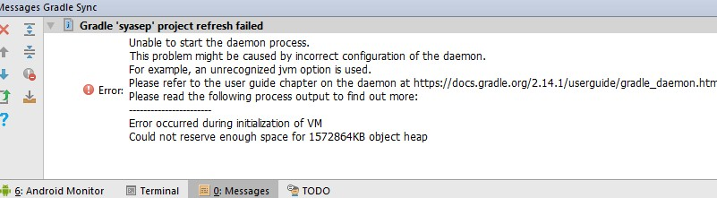
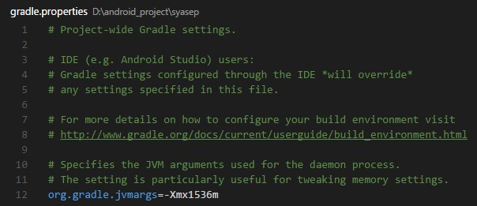
org.gradle.jvmargs=-Xmx512m

